

An-Najah National University Department of Computer Engineering Distributed Operating Systems

Homework 1

Alaa kayed

Mahmoud shaban

# Program Design:

Firstly to build our API we used Django Rest Framework because it is more suitable with SQL Databases and it is easy and powerful.

1. Then we started to work on the ***catalog server*** and implemented its functionality step by step as follows:
   1. 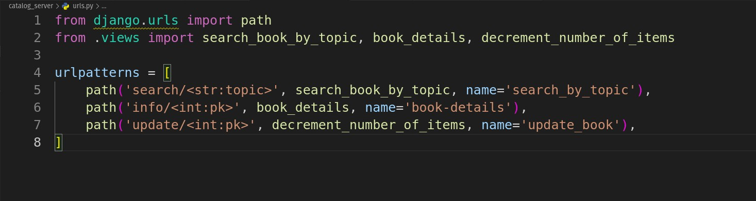We created the needed endpoints which is represent the following functionality ***search(topic) , info(item_number) and decrement_number_of_books(item_number)*** as shown below :
   2. we implemented the ***search(topic)*** functionality :

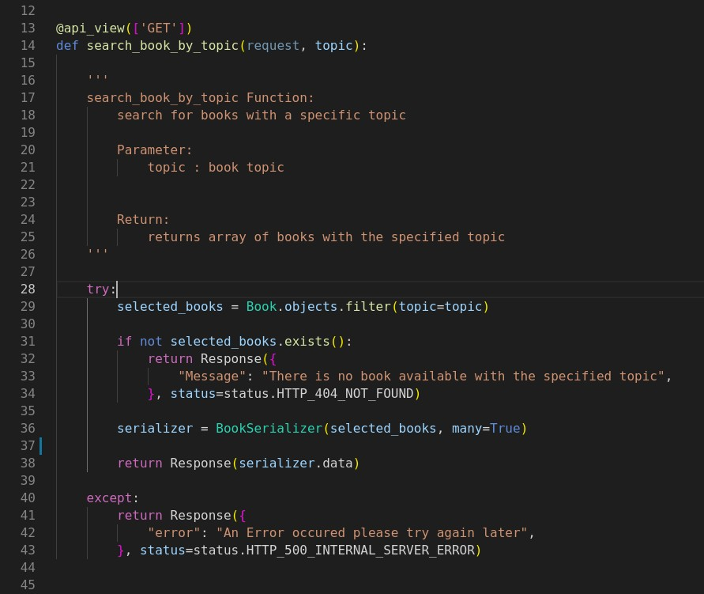

* 1. we implemented the ***info(item_number)*** functionality :

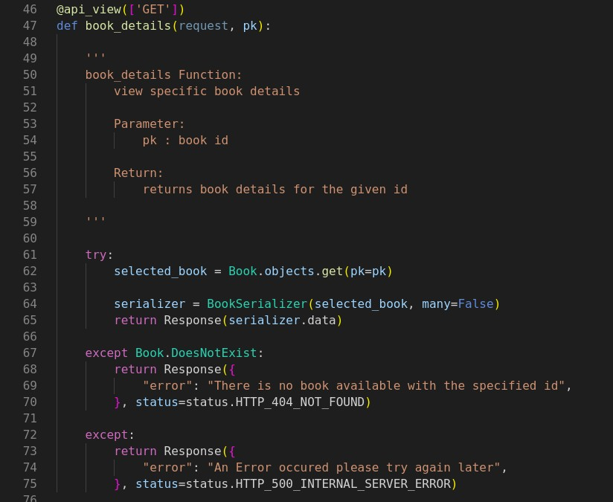

* 1. we implemented the last endpoint which is

***decrement_number_of_books(item_number)***

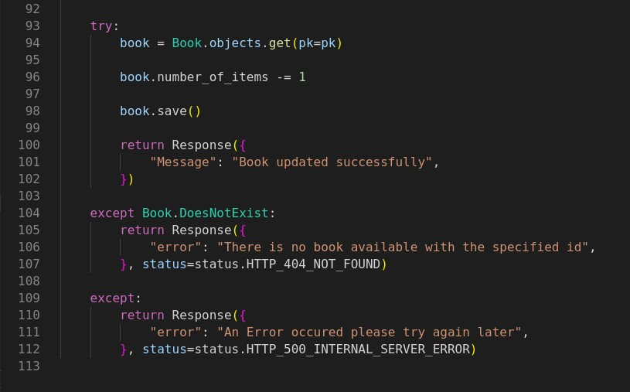

* 1. We deployed our catalog server on Heroku

1. 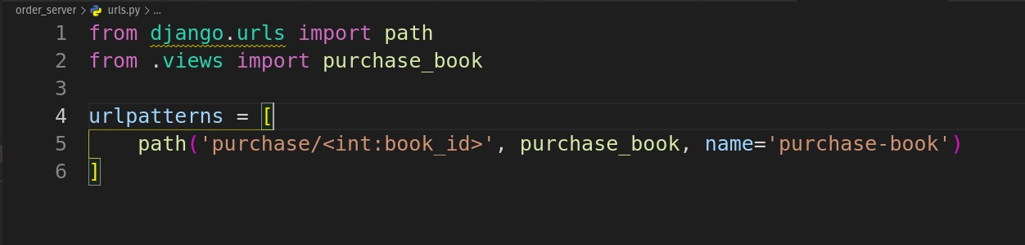Then we started to work on the ***Order server*** and added the only endpoint which is ***purchase(item_number):***

then we implemented the functionality of the purchase(item_number):

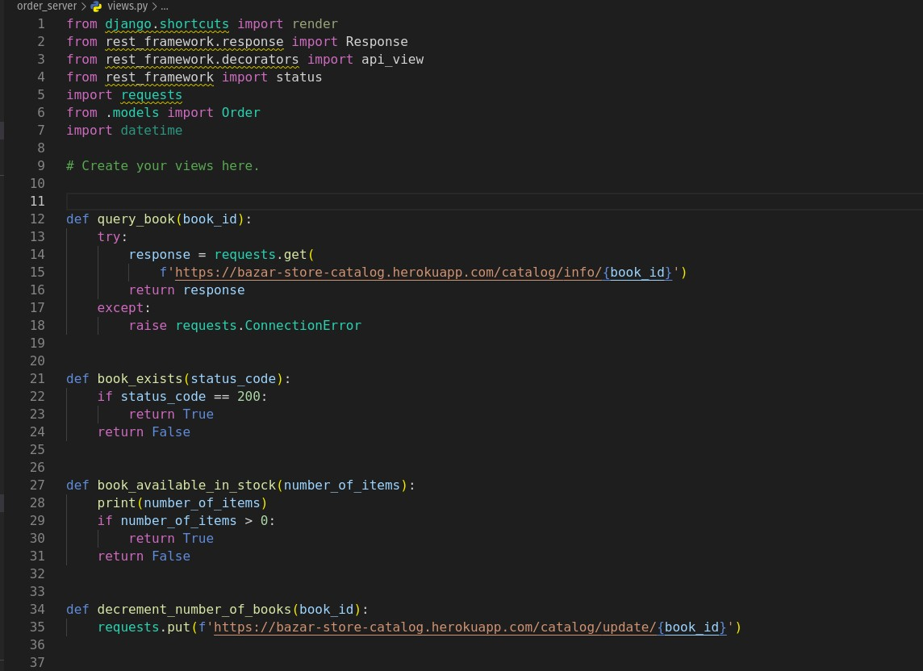

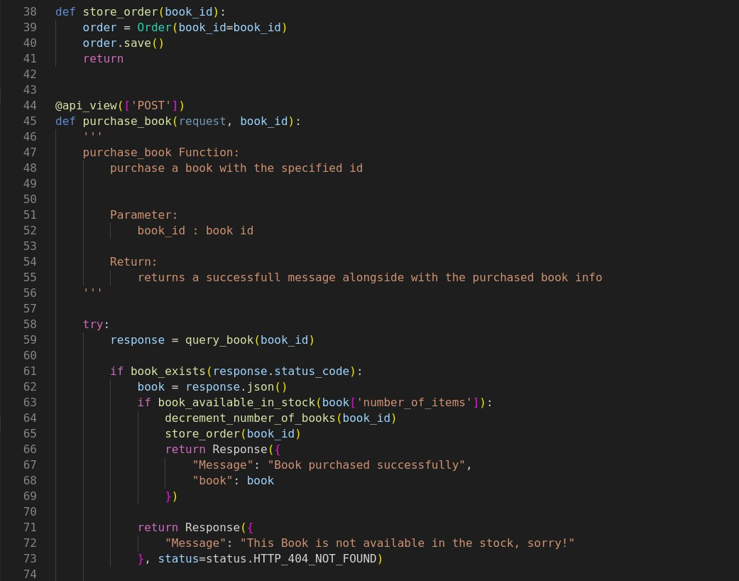

# Improvement Suggestion

I think that we can reduce the number of requests from order server to catalog server by just send one request and this request checks for book availability and at the same time update the number of books.

# Endpoints Reference :

1. Catalog Server:

## GET

[https://bazar-store-catalog.herokuapp.com/catalog](https://bazar-store-catalog.herokuapp.com/catalog/search/Undergraduate%20School)

[/search/](https://bazar-store-catalog.herokuapp.com/catalog/search/Undergraduate%20School){topic name}

## GET

[https://bazar-store-catalog.herokuapp.com/catalog](https://bazar-store-catalog.herokuapp.com/catalog/info/4)

[/info/](https://bazar-store-catalog.herokuapp.com/catalog/info/4){item_number}

## PUT

[https://bazar-store-catalog.herokuapp.com/catalog](https://bazar-store-catalog.herokuapp.com/catalog/update/4)

[/update/](https://bazar-store-catalog.herokuapp.com/catalog/update/4){item_number}

1. Order Server:

## POST

[https://bazar-order-server.herokuapp.com/ord](https://bazar-order-server.herokuapp.com/order-server/purchase/4) [er-server/purchase/](https://bazar-order-server.herokuapp.com/order-server/purchase/4){item_number}

